**MAC Excel 2011**

Contents

Conditional Formatting 3

Basic 3

Gradient Fills 3

Clear Rules 5

Color Scales 6

Icons 7

References 9

# Conditional Formatting

## Basic

### Gradient Fills

Highlight the required cells B2:B20

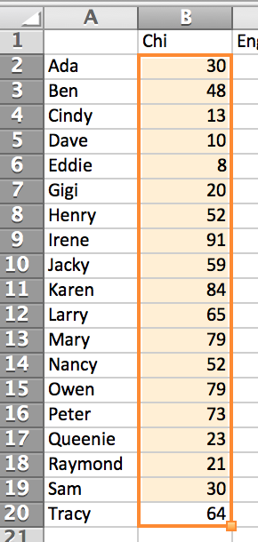

Home ribbon -> Conditional Formatting -> Data Bars -> Gradient Fill -> Blue

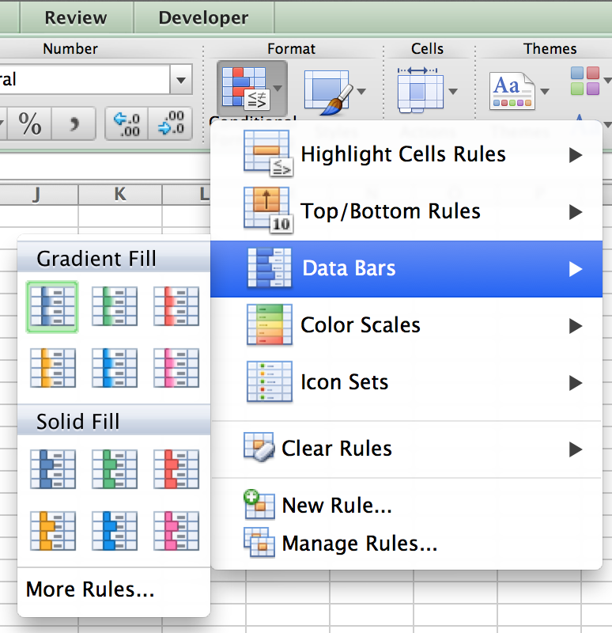

Gradient Fill as cell background

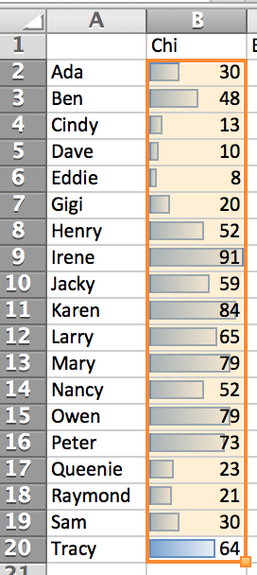

You can choose other colors or solid fill.

### Clear Rules

Clear the rules. Conditional Formatting -> Clear Rules -> Clear Rules from Selected Cells.

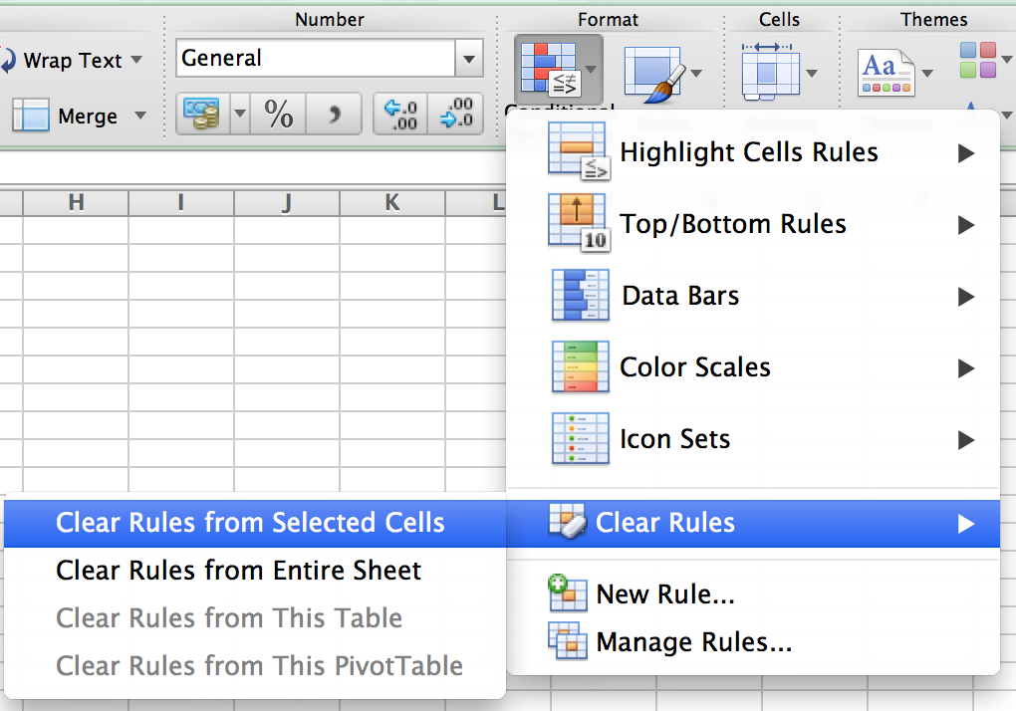

You don’t need to clear rules if you want to use both conditional Formatting styles.

### Color Scales

Another way to display the result by Color Scales. Conditional Formatting -> Color Scales -> Green – Yellow – Red Color Scale.

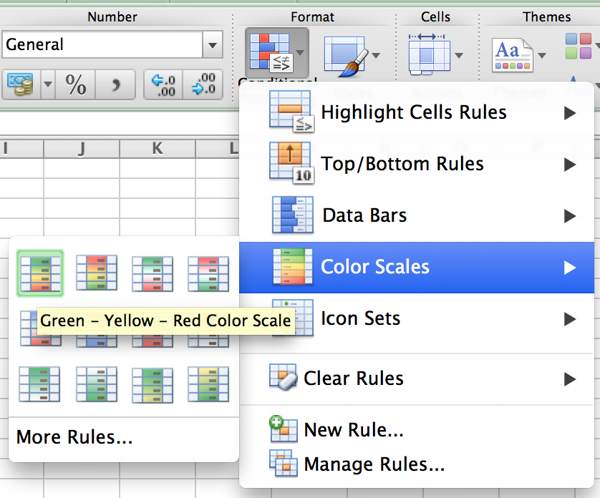

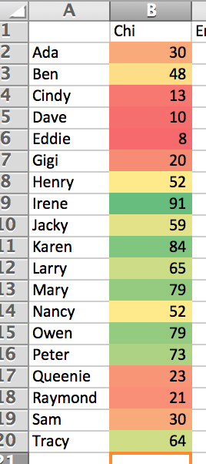

### Icons

But the problem of using Data Bars or Color Scales is that when you print it out, you can only see the grey scale in black and white printer. If this is the case, you may use icons. Conditional Formatting -> Icons -> Directions / Shapes / Indicators / Ratings

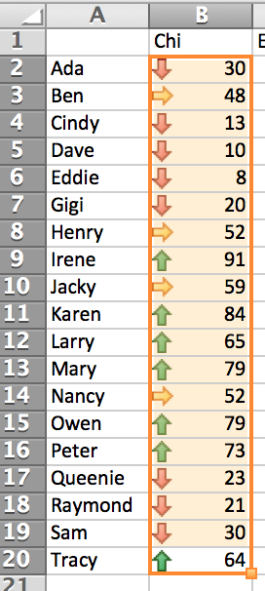

# Formulas

## Help

### Formula Builder

If you want to get help with a short description, you can use Formulas -> Functions -> Formula Builder.

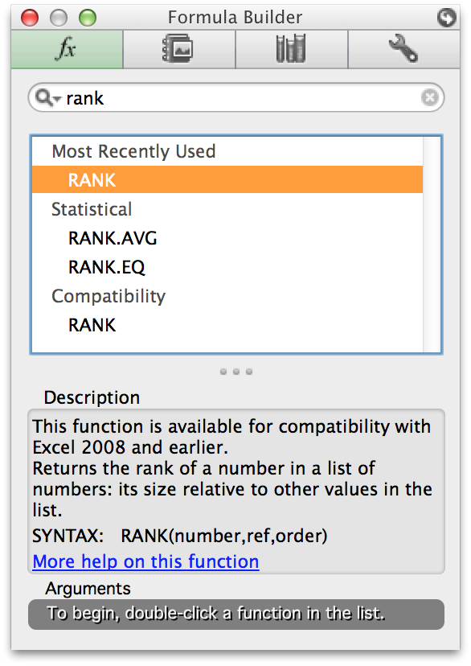

### Reference

If you don’t know which formula fits you, you can use Formulas -> Function -> Reference to check.

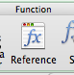

Search what you are looking for. Then it will give you some suggestions.

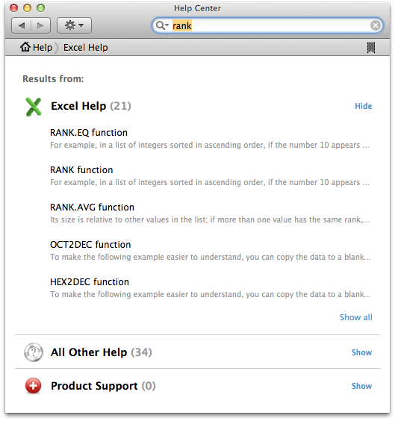

## Basic

### SUM

Adds all the numbers in a range of cells.

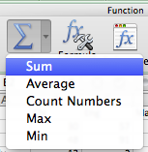

=SUM(B3:D3)

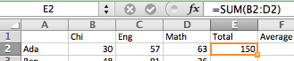

### AVERAGE

Returns the average (arithmetic mean) of the arguments.

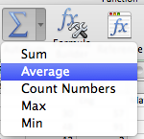

=AVERAGE(B2:D2)

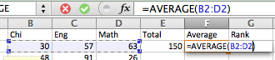

### RANK

Returns the rank of a number in a list of numbers. The rank of a number is its size relative to other values in a list.

=RANK(F2,$F$2:$F$20)

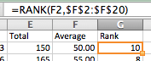

### VLOOKUP

Searches for a value in the first column of a table array and returns a value in the same row from another column in the table array.

#### Syntax

**VLOOKUP**(**lookup_value**,**table_array**,**col_index_num**,range_lookup)

**Lookup_value**    The value to search in the first column of the table [array](javascript:AppendPopup(this,'484728516_1')). Lookup_value can be a value or a reference. If lookup_value is smaller than the smallest value in the first column of table_array, VLOOKUP returns the #N/A error value.

**Table_array**    Two or more columns of data. Use a reference to a range or a range name. The values in the first column of table_array are the values searched by lookup_value. These values can be text, numbers, or logical values. Uppercase and lowercase text are equivalent.

**Col_index_num**    The column number in table_array from which the matching value must be returned. A col_index_num of 1 returns the value in the first column in table_array; a col_index_num of 2 returns the value in the second column in table_array, and so on. If col_index_num is:

* Less than 1, VLOOKUP returns the #VALUE! error value.
* Greater than the number of columns in table_array, VLOOKUP returns the #REF! error value.

**Range_lookup**    A logical value that specifies whether you want VLOOKUP to find an exact match or an approximate match:

* If TRUE or omitted, an exact or approximate match is returned. If an exact match is not found, the next largest value that is less than lookup_value is returned.

#### VLOOKUP1

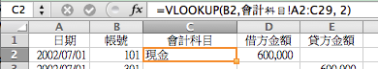

=VLOOKUP(B2,會計科目!A2:C29, 2)

# References

Orientation

<http://developer.android.com/guide/topics/manifest/activity-element.html>